Carlos Lazo

ECE 503

Homework #2

Due: 2/1/10

1. **Convolution Sum**

**b.** P&M 2.16 (b)(5):

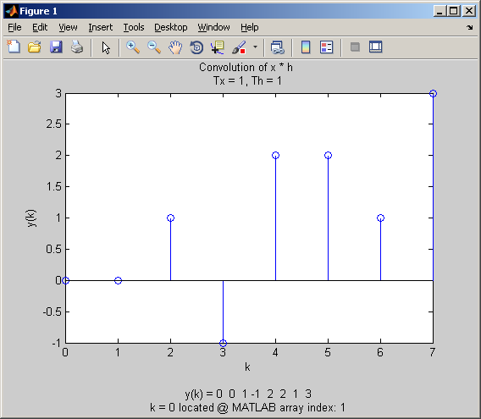

**b.** P&M 2.16 (b)(10):

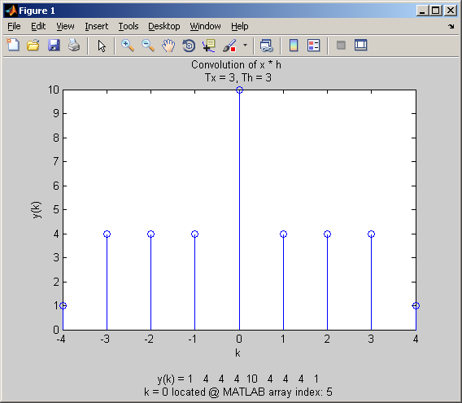

**c.** P&M 2.22(a)(y2):

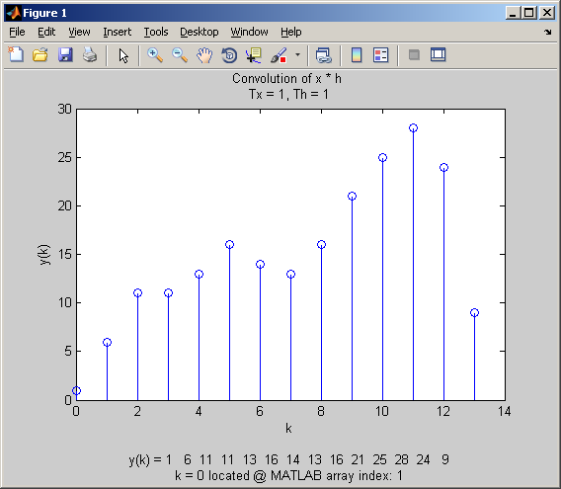

**c.** P&M 2.22(a)(y4):

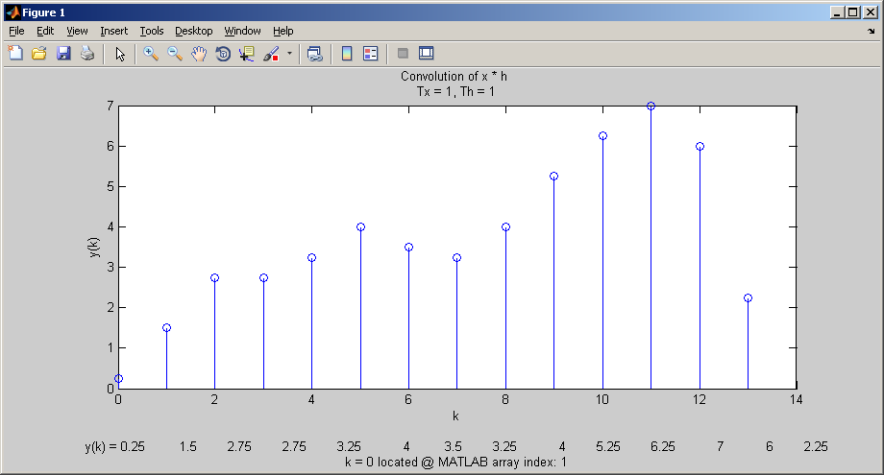

1. **Forward Z-Transforms**

**d.** MATLAB Plot of Z-transform magnitude: x(k) = ak * u(k) when a = 0.5

